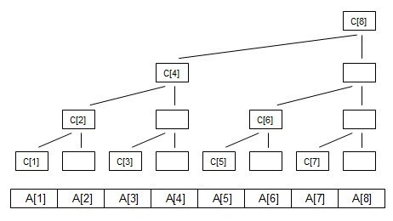
k为二进制末尾0的个数

树状数组 二进制 k 2^{k}
tree[1] = A[1] 001 0 1
tree[2] = A[1] + A[2] 010 1 2
tree[3] = A[3] 011 0 1
tree[4] = A[1] +A[2] +A[3]+A[4] 100 2 4
tree[5] = A[5] 101 0 1
tree[6] = A[5] +A[6] 110 1 2
tree[7] = A[7] 111 0 1
tree[8] = A[1] +A[2] +A[3]+A[4]+A[5] +A[6] +A[7] +A[8] 1000 3 8

求和: 二进制
sum(1) = tree[1] 001 001
sum(2) = tree[2] 010 010
sum(3) = tree[3] + tree[2] 011 011 + 010
sum(4) = tree[4] 100 100
sum(5) = tree[5] + tree[4] 101 101 + 100
sum(6) = tree[6] + tree[4] 110 110 + 100
sum(7) = tree[7]+tree[6]+tree[4] 111 111 + 110 + 100
sum(8) = tree[8] 1000 1000

lowbit操作：
例如7
lowbit（7） = 1； cur + tree[7]
7 - 1 = 6；
lowbit （6） = 2； cur+ tree[6]
6 - 2 = 4；
lowbit（4） = 4； cur+ tree[4]
4 - 4 = 0；

代码：

#include <bits/stdc++.h>

using namespace std;

const int maxn = 50005;
int tree[maxn];
int n;
int lowbit(int x)
{
return x&(-x);
}

//从叶子节点向上更新 例如 add(1,x) tree[001] -> tree[010] -> tree[100]
//需要更新1->2->4
void add(int i,int value)
{
while(i<=n)
{
tree[i]+=value;
i+=lowbit(i);
}
}

//从根节点向下加和
//求sum(8)=tree[1000] sum(7)=tree[111]+tree[110]+tree[100]= tree7+tree6+tree4
int sum(int i)
{
int cur = 0;
while(i>0)
{
cur += tree[i];
i-=lowbit(i);
}
return cur;
}
int main()
{
int T;
scanf("%d",&T);
for(int i=1;i<=T;i++)
{
memset(tree,0,sizeof(tree));
scanf("%d",&n);
for(int j=1;j<=n;j++)
{
int x;
scanf("%d",&x);
add(j,x);
}
printf("Case %d:\n",i);
string s;
while(cin>>s)
{
if(s=="End")
break;
else if(s=="Query")
{
int x,y;
scanf("%d%d",&x,&y);
printf("%d\n",sum(y)-sum(x-1));
}
else if(s=="Add")
{
int pos,value;
scanf("%d%d",&pos,&value);
add(pos,value);
}
else if(s=="Sub"){
int pos,value;
scanf("%d%d",&pos,&value);
add(pos,-value);
}
}
}
return 0;
}

